Travelling the World through Music
Name:
My reflection:

If I could travel to South America, I would like to go to:
____________________ so that I could _________
_________________________________________

My favourite song was _____________________
because _________________________________

My favourite instrument was _________________
because _________________________________

I would like to know more about _______________
because _________________________________

We are travelling around

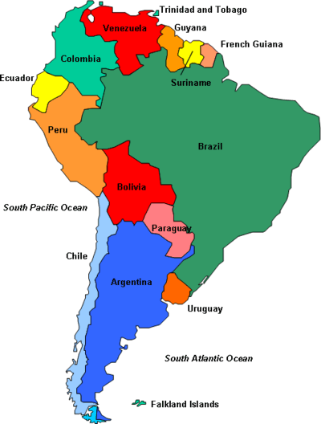

Interesting facts about South America

La Mariposa (Bolivia)

Vengan a cantar La Morenada que empieza a sonar.
Como el vuelo de una mariposa, vamos todos a bailar.

Con las manos, Con los pies. La Morenada

La araňa picua (Colombia)

La araňa te va a picar
Sujetala por detras
La araňa te va a morder
Sujetala por los pies

African Instruments

Music in South America

Song

South American Instruments

A Luz de Tieta (Brasil)
