Travelling the World through Music

We are travelling around
Name:
My reflection:

If I could travel to North and Central America, I would
like to go to:__________ so that I could _________
_________________________________________

My favourite song was _____________________
because _________________________________

My favourite instrument was _________________
because _________________________________

I would like to know more about _______________
because _________________________________

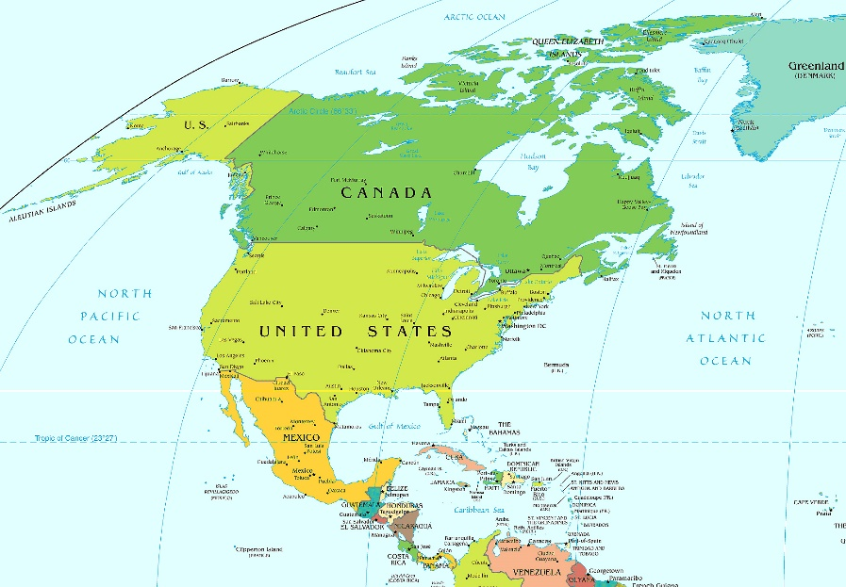

Interesting facts about North and Central America

Mardi Gras Mambo (USA)

Down in New Orleans, where the Blues was born.
It takes a cool cat to blow a horn.
…
Mardi Gras Mambo, Mambo, Mambo…down in New Orleans

Hanal Weech (Mexico)

African Instruments

Music in North America

Song

Music in Central America

North American Instruments

Central American Instruments

Guantanamera (Cuba)

Guantanamera, Guajira Guantanamera,

Yo soy un hombre sincere, de donde crece la plama.
Y antes de morirme quiero, echar mis versos del alma.

