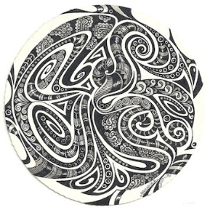
Songs and history
“Performers research and learn about the origins of music to add
meaning to their performances”

Title: ____________________________
Type of song:______________________
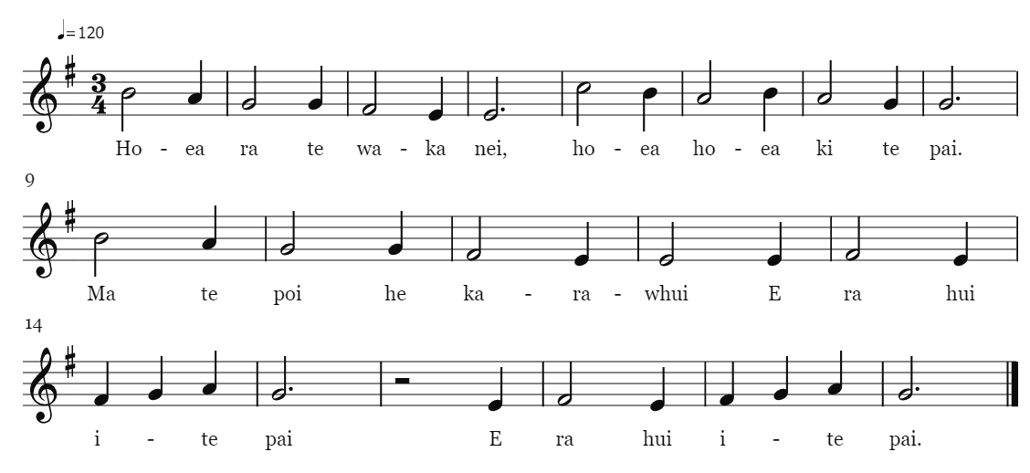
Pitch and fingering:

What would we like to know about this song?

What have we found out about this song?

Based on our research, we have decided to play this song:

(Choose at least three adjectives that describe how you will play the song)
Interesting resources for our presentation (include websites, photos, videos or audios)

Songs and history
“Performers research and learn about the origins of music to add
meaning to their performances”

Title: ____________________________
Type of song:______________________
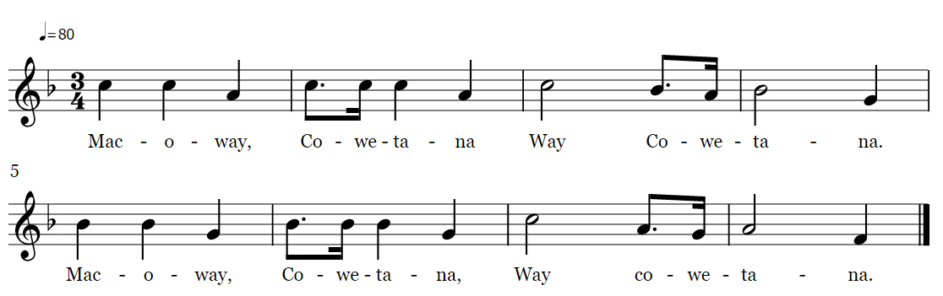

Pitch and fingering:

What would we like to know about this song?

What have we found out about this song?

Based on our research, we have decided to play this song:

(Choose at least three adjectives that describe how you will play the song)
Interesting resources for our presentation (include websites, photos, videos or audios)

Songs and history
“Performers research and learn about the origins of music to add
meaning to their performances”

Title: ____________________________
Type of song:______________________
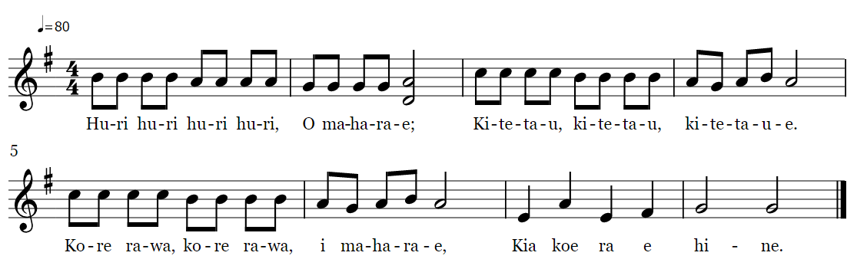

Pitch and fingering:

What would we like to know about this song?

What have we found out about this song?

Based on our research, we have decided to play this song:

(Choose at least three adjectives that describe how you will play the song)
Interesting resources for our presentation (include websites, photos, videos or audios)

Songs and history
“Performers research and learn about the origins of music to add
meaning to their performances”

Title: ____________________________
Type of song:______________________
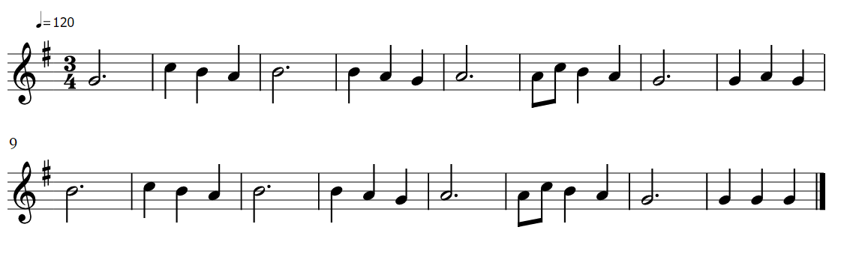

Pitch and fingering:

What would we like to know about this song?

What have we found out about this song?

Based on our research, we have decided to play this song:

(Choose at least three adjectives that describe how you will play the song)
Interesting resources for our presentation (include websites, photos, videos or audios)

Songs and history
“Performers research and learn about the origins of music to add
meaning to their performances”

Title: ____________________________
Type of song:______________________
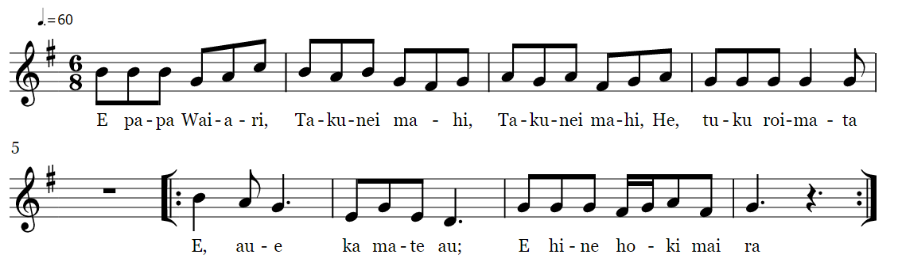

Pitch and fingering:

What would we like to know about this song?

What have we found out about this song?

Based on our research, we have decided to play this song:

(Choose at least three adjectives that describe how you will play the song)
Interesting resources for our presentation (include websites, photos, videos or audios)

