Name __________________________ Grade ______ Date _________

Unit____________________

Listening Guide

Title: _______________________ Composer:_______________



What does this music sound like? What do you think it is describing?

**Adjectives Describing**

1.

2.

3.

4.

5.

6.

7.

*We are* ***Knowledgeable***







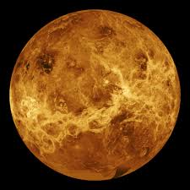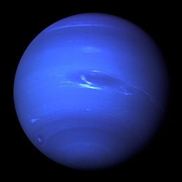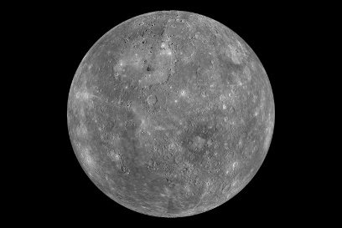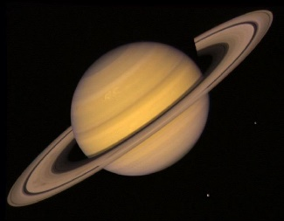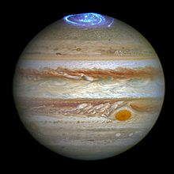

Mysterious

**Mercury, the Winged Messenger**

Creepy dance

Slow, serious

Cheerful, Majestic

Light, fast

Gentle, relaxing

Angry, scary

**Saturn, the Bringer of Old Age**

**Neptune, the Mystic**

**Jupiter, the Bringer of Jollity**

**Uranus, the Magician**

**Mars, the Bringer of War**

**Venus, the Bringer of Peace**

6

5

7

4

2

3

1