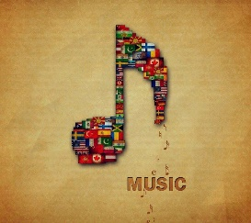
Travelling the World through Music

We are travelling around
Name:
My reflection:

If I could travel to Africa, I would like to go to:
____________________ so that I could _________
_________________________________________

My favourite song was _____________________
because _________________________________

My favourite instrument was _________________
because _________________________________

I would like to know more about _______________
because _________________________________

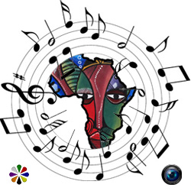

Interesting facts about Africa

Jambo Bwana (Kenya)
Jambo, Jambo Bwana Hello, hello Sir
Habari gani, mzuri sana How are you, Fine, thank you
Tuimbe, tucheze sote Let us sing, let us all dance
Kiswahili, ni lugha ya Africa Swahili is the language of Africa

Hello, Hello (Congo)

African Instruments

Music in Africa

Song

African Instruments

Fatou Yo (Senegal)
Fatou yo si dia dialano I am Fatou, pretty Fatou
Fatou faye faye fatou Fatou oh, oh Fatou,
Fatou kélémen dio Like all the children of the world
Fatou yo si dia dialano I am Fatou, pretty Fatou.
Boutoumbélé boutoumbélé I am happy and will surely grow
Boutoumbélé o ma mi se ra I will grow up like everybody else
O Ma mycasse boutoumbélé Like the little elephants and the l little giraffes

