Name___________________________________________ Grade_________ Date________
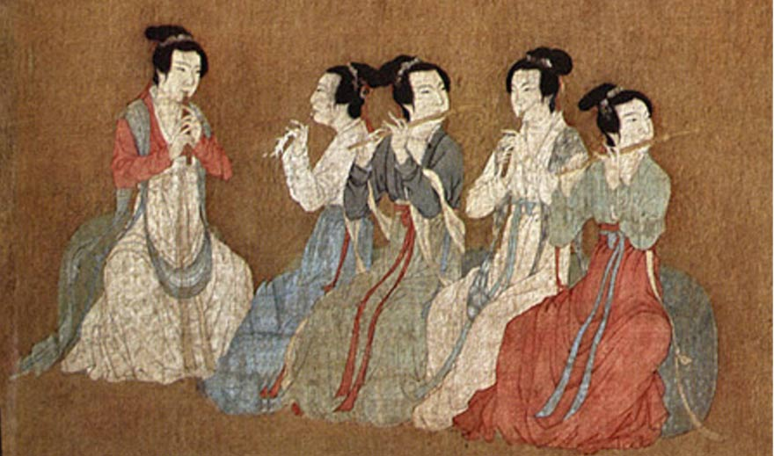
Ancient China
Musical element focus:

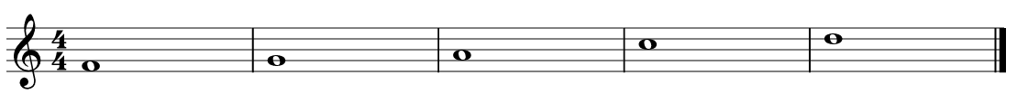
D
C
A
G
F

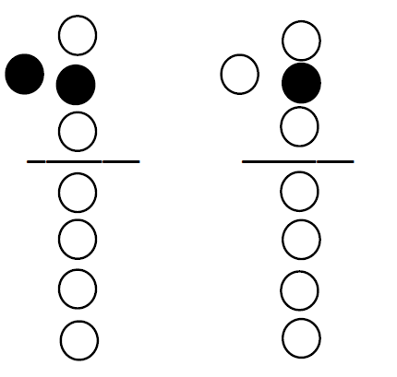
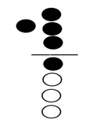
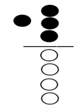
Left

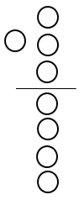
Right

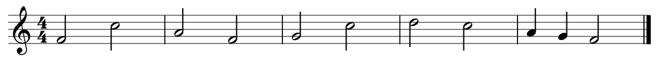
Use the information above to identify the following notes as well as the recorder fingerings:

With the information from the previous page, now you can try to play the following
Chinese Folk songs:

Ai Hai Yo
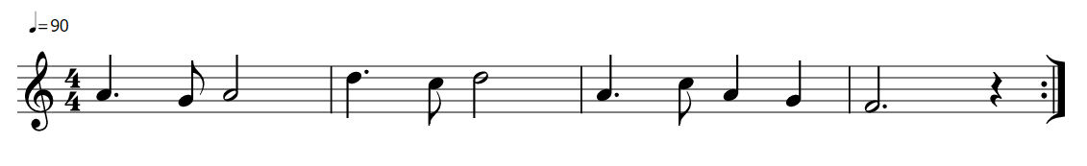

Fukien Boat Song
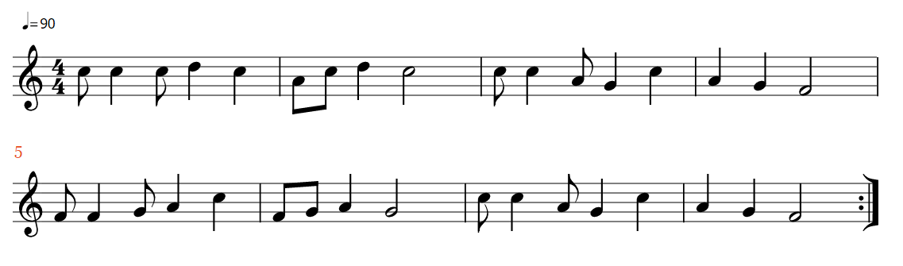

Song of the Dragon
