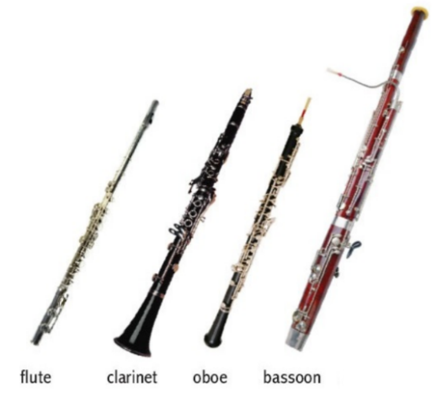

*WOODWINDS*

________________________________

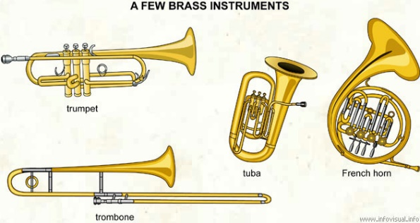

*BRASS*

_______________________________