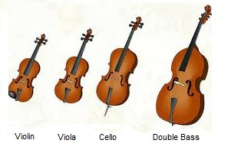

***STRINGS***

**________________________________________**

**The Orchestra**

