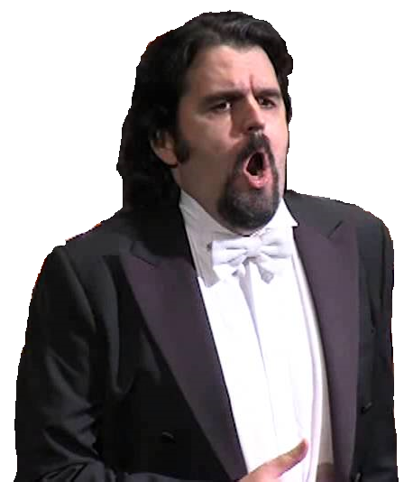
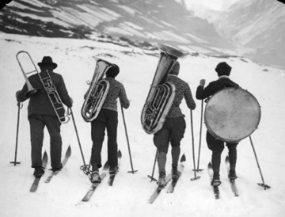
Musical Migrants
Pedro Carrillo

Answer questions 1-3 individually and discuss question 4 with your group
Part 1 (stop at 5:05)
1) How long ago did Pedro and Victoria come to Milan?
2) What was Pedro’s goal in life as a child?
3) What animal does Pedro say the audience was like after his first performance?
4) What are the reasons you could imagine leaving your own country later in life?

Part 2 (stop at 11:47)
1) Why didn’t the President of the Theater want Pedro to work with them anymore?
2) What did Pedro find difficult about going to Italy with a scholarship?
3) What is “La Scala”?
4) What else can you hear in the interview other than Pedro speaking?

Part 3 (stop at 17:31)
1) How long did it take Pedro to make his life go from “darkness to light”?
2) Finish the advice the Old Soprano gave Pedro – “Yes you have the voice, but….”
3) Why does Pedro think it is “fundamental for a singer to sing in Italy”?

4) What are ways a city or country can offer opportunities than another place cannot?

Part 4
1) What were the reviews and comments like after Pedro’s first big performance?
2) How is Pedro preparing himself for his new challenge?
3) How does Pedro describe the feeling of having support from his home country in Milan?
4) In what ways do you feel support from your own country?

Explain briefly how music represented challenges, risks and /or opportunities for Jesse Lee Jones

