Name __________________________ Grade ______ Date _________

Unit____________________ Listening Guide

*We are* ***Knowledgeable***

*We are* ***Inquirers***

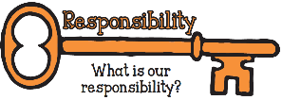

**What do you think these artists had to do to become so good at playing their instruments?**

**What would you ask these artists if you could meet them?**

* Lang Lang

* Emmanuel Pahud

* Joe Satriani
* Find another instrumental player you like.

Communicator

Enthusiasm

Risk-taker

Commitment

Reflection

Principled

Responsibility

Central Idea

Performers practice and reflect to improve their skills and increase the expressive content of their performances.

*We are* ***Thinkers***

Connect the words in the boxes (key concepts, learner profile attributes and attitudes) to specific words within the central idea and why you think they are connected:

