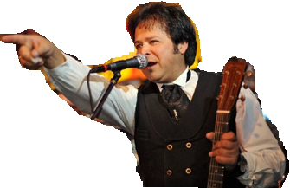
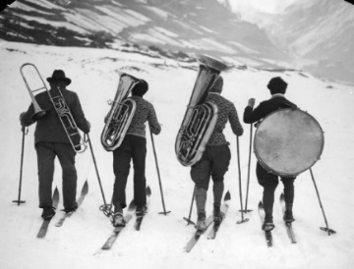
Musical Migrants
Jesse Lee Jones

Answer questions 1-3 individually and discuss question 4 with your group
Part 1 (stop at 5:34)
1) What kind of music does Jesse love?
2) Where did Jesse first perform with his guitar?

3) Where did Jesse take a plane to?
4) What challenges do we face coming to a new country?

Part 2 (stop at 11:20)
1) How did Jesse get to Peoria, Illinois?
2) Why were the police called to talk to Jesse?
3) What people took Jesse into their house?
4) How can meeting people in a new country help you adjust to a new life?

Part 3 (stop at 17:13)
1) Where was the birthplace of country music?
2) Why does Jesse admire Marty Robbins so much?
3) What did Jesse do for work when he first got to Nashville?
4) Who are people from other countries you admire?

Part 4
1) How did Jesse get to play for his first time at “Robert’s Western World?”

2) Why does Jesse have the nickname the “Brazil-billy?”
3) How did Jesse come to own “Robert’s Western World?”
4) How can moving to a new country change us?
Explain briefly how music represented challenges, risks and /or opportunities for Jesse Lee Jones

